**Candidate’s Name:**

|  |  |  |  |  |  |  |  |
| --- | --- | --- | --- | --- | --- | --- | --- |
| **Random No.** | | | | | **Personal No.** | | |
|  |  |  |  |  |  |  |  |

……………………………………………..

**Signature:** …………………………………

***(Do not write your School/Centre Name or Number anywhere on this booklet)***

**P525/1**

**CHEMISTRY**

**Paper 1**

2 ¾ hours

**Uganda Advanced Certificate of Education**

**CHEMISTRY**

**Paper 1**

**2 hours 45 minutes**

**INSTRUCTIONS TO CANDIDATES**:

*Answer* **all** *questions in section* **A** *and* **six** *questions in section* **B**

*All questions must be answered in the spaces provided*

*The Periodic Table, with relative atomic masses, is supplied.*

*Mathematical tables(3 – figure tables) are adequate or non-programmable scientific electronic calculators may be used*

*Illustrate your answers with equations where applicable.*

*Where necessary, use the following:*

*Molar gas constant R = 8.31 JK-1 mol-1*

*Molar volume of a gas at s.t.p is 22.4 litres.*

*Standard temperature = 273 K*

*Standard pressure = 101325 N m-2*

|  |  |  |  |  |  |  |  |  |  |  |  |  |  |  |  |  |  |
| --- | --- | --- | --- | --- | --- | --- | --- | --- | --- | --- | --- | --- | --- | --- | --- | --- | --- |
| **For Examiner’s Use Only** | | | | | | | | | | | | | | | | | |
| 1 | 2 | 3 | 4 | 5 | 6 | 7 | 8 | 9 | 10 | 11 | 12 | 13 | 14 | 15 | 16 | 17 | Total |
|  |  |  |  |  |  |  |  |  |  |  |  |  |  |  |  |  |  |

**Turn Over**

**SECTION A (46 MARKS)**

1. a) Methylamine is a weak base

i) What is **weak base**? *(1 mark)*

..........................................................................................................................................

..........................................................................................................................................

ii) Write the equation for the ionization of methylamine. *(1 mark)*

..........................................................................................................................................

..........................................................................................................................................

iii) Write the expression for the ionization constant of methylamine. *(1 mark)*

..........................................................................................................................................

..........................................................................................................................................

b) i) Calculate the hydrogen ion concentration in a 0.02M solution of methylamine. (*Kb = 4.4 × 10-4; Kw = 1 x 10-14 at 25oC*). *(3 marks)*

..........................................................................................................................................

..........................................................................................................................................

..........................................................................................................................................

..........................................................................................................................................

..........................................................................................................................................

..........................................................................................................................................

ii) Calculate the pH of the solution. *(1 mark)*

..........................................................................................................................................

..........................................................................................................................................

2. Name the reagent that you would use to distinguish between the following pairs of compounds. In each case state what you would observe when the reagent is treated with each member of the pair.

a) (CH3CH2)2NH and CH3CH2NH2*(2 marks)*

***Reagent:***

..........................................................................................................................................

***Observations:***

..........................................................................................................................................

..........................................................................................................................................

..........................................................................................................................................

b) CH3CH2OH and CH3OH *(2 marks)*

***Reagent:***

..........................................................................................................................................

***Observations:***

..........................................................................................................................................

..........................................................................................................................................

..........................................................................................................................................

c) HCOOH and CH3COOH *(2 marks)*

***Reagent:***

..........................................................................................................................................

***Observations:***

..........................................................................................................................................

..........................................................................................................................................

3. Write the ionic equation for the reaction between sodium hydroxide and

(a) Silicon(IV) oxide *(1 ½ marks)*

..........................................................................................................................................

(b) Aluminium *(1 ½ marks)*

..........................................................................................................................................

(c) Zinc oxide *(1 ½ marks)*

..........................................................................................................................................

4. a) i) Define a ‘**complex ion**’. *(2 marks)*

..........................................................................................................................................

..........................................................................................................................................

ii) Explain why transition metals form complexes. *(2 marks)*

..........................................................................................................................................

..........................................................................................................................................

..........................................................................................................................................

..........................................................................................................................................

(b) Complete the following table about complexes of chromium and cobalt. *(2 marks)*

|  |  |  |
| --- | --- | --- |
| **Complex** | **Oxidation state of metal ion** | **Co-ordination number** |
| [Cr(NH3)6]3+ |  |  |
| [CO(NH3)4(H2O)2]C*l*2 |  |  |

5. State what you would observe and write an ionic equation for the reaction between aqueous copper(II) sulphate solution and:

(a) Excess concentrated hydrochloric acid *(2 ½ marks)*

***Observation***

..........................................................................................................................................

***Equation***

..........................................................................................................................................

(b) Aqueous potassium iodide solution. *(2 ½ marks)*

***Observation***

..........................................................................................................................................

***Equation***

..........................................................................................................................................

6. Excess magnesium was added to 100 cm3 of 0.2 M copper (II) sulphate solution. The temperature rose by 16.9 oC.

a) Write an equation for the reaction. *(1½ marks)*

..........................................................................................................................................

(b) Calculate the enthalpy of the reaction. *(Density of the solution is 1.0 g/cm3. Specific heat capacity of the solution is 4.2 J/g/oC).*  *(2½ marks)*

..........................................................................................................................................

..........................................................................................................................................

..........................................................................................................................................

..........................................................................................................................................

..........................................................................................................................................

7. a) Define:

i) **Bond energy**. *(1 mark)*

..........................................................................................................................................

..........................................................................................................................................

ii) **Heat of formation**. *(1 mark)*

..........................................................................................................................................

..........................................................................................................................................

(b) Given the following bond energies.

|  |  |
| --- | --- |
| **Bond** | **Bond energy (kJ/mole)** |
| C – C | 337 |
| C – H | 414 |
| C – O | 360 |
| O – H | 123 |

Calculate the heat of conversion of gaseous methoxymethane to gaseous ethanol. *(2 marks)*

..........................................................................................................................................

..........................................................................................................................................

..........................................................................................................................................

..........................................................................................................................................

8. a) An alkyne X has molecular formula C4H6. Write the names and structural formulae of all possible isomers of X. *(2 marks)*

..........................................................................................................................................

.........................................................................................................................................

(b) **X** reacts with an ammoniacal solution of silver nitrate.

i) State what is observed. *(½ mark)*

.........................................................................................................................................

ii) Write the equation for the reaction that takes place. *(1 mark)*

..........................................................................................................................................

c) Write equations to show how **X** can be synthesized from ethane. (*4 marks)*

..........................................................................................................................................

.........................................................................................................................................

..........................................................................................................................................

.........................................................................................................................................

9. Draw the molecular structures of the following species. (*2 marks)*

|  |  |
| --- | --- |
| **species** | **Shape** |
| (a) SO3 |  |
| (b) C*l*2 |  |
| (c) H2S |  |
| (d) SO42- |  |

**SECTION B: (54 MARKS)**

*Answer* **six** *questions from this section.*

*Additional questions answered will* **not** *be marked.*

10. Write equations to show how the following compounds can be synthesized. Indicate the reagents and conditions.

a) (CH3)2C = NOH from propane – 2 – ol. *(2 marks)*

..........................................................................................................................................

.........................................................................................................................................

..........................................................................................................................................

 *(3 marks)*

b)

..........................................................................................................................................

.........................................................................................................................................

..........................................................................................................................................

.........................................................................................................................................

.........................................................................................................................................

c) CH3CH2C ≡ CCH2CH2CH3 from But-l-ene. *(2 marks)*

..........................................................................................................................................

.........................................................................................................................................

..........................................................................................................................................

d) Benzoic acid from chlorobenzene. *(2 marks)*

..........................................................................................................................................

.........................................................................................................................................

11. (a) Write the formula and name of **one** ore of aluminium. *(1 mark)*

..........................................................................................................................................

(b) In the extraction of aluminium, the ore is first digested with sodium hydroxide solution. Describe what happens and write equations for the reactions that take place. *(3 marks)*

..........................................................................................................................................

.........................................................................................................................................

..........................................................................................................................................

.........................................................................................................................................

.........................................................................................................................................

(c) Name the steps that are carried out after digesting the ore with sodium hydroxide. *(3 marks)*

..........................................................................................................................................

.........................................................................................................................................

..........................................................................................................................................

.........................................................................................................................................

.........................................................................................................................................

(c) Describe how pure aluminium is obtained from the purified ore. Write the equation for the reaction. *(2 marks)*

..........................................................................................................................................

.........................................................................................................................................

..........................................................................................................................................

12. a) Define

i) **Conductivity**. *(1 mark)*

..........................................................................................................................................

.........................................................................................................................................

ii) **Molar conductivity**  *(1 mark)*

..........................................................................................................................................

.........................................................................................................................................

(b) The electrolytic conductivity of a 0.1 M ethanoic acid at 20o C is 1.96 x 10-2 Sm-1. Its molar conductivity at infinite dilution is 3.52 x 10-2 S m2 mol-1.

Calculate:

i) The molar conductivity of ethanoic acid at 20oC. *(2 marks)*

..........................................................................................................................................

.........................................................................................................................................

ii) The degree of ionization of the acid at 20oC. *(1 mark)*

..........................................................................................................................................

.........................................................................................................................................

iii) The pH of the acid *(2 marks)*

..........................................................................................................................................

.........................................................................................................................................

(c) State **two** other factors other than concentration that can affect the pH of the acid. *(2 marks)*

..........................................................................................................................................

.........................................................................................................................................

13. a) State **three** properties exhibited by chromium as a transition metal. *(3 marks)*

.........................................................................................................................................

..........................................................................................................................................

.........................................................................................................................................

(b) An aqueous solution of iron (II) salt was added to an acidified solution of chromium in the oxidation state of +6.

i) State what was observed. *(1 mark)*

.........................................................................................................................................

ii) Write half equations and the overall equation for the reaction that took place *(3 ½ marks)*

.........................................................................................................................................

..........................................................................................................................................

.........................................................................................................................................

(c) i) State **one** application of chromium in the oxidation state of +6 in organic synthesis. *(½ mark)*

.........................................................................................................................................

ii) Write the equation to illustrate your answer. *(1 mark)*

.........................................................................................................................................

14. Hydrogen iodide decomposes according to the equation.

2HI(g) H2(g) + I2(g) H = +11.3 kJ/mol.

a) Write an expression for the equilibrium constant (Kc) of the reaction. *(½ mark)*

.........................................................................................................................................

(b) 2.56 g of hydrogen iodide was heated in a 600 cm3 bulb at 500 oC. At equilibrium the bulb was rapidly cooled to room temperature and broken under potassium iodide solution. The iodine liberated required 33.5 cm3 of 0.2 M sodium thiosulphate for complete reaction. Calculate

i) The number of moles of hydrogen iodide that were heated. *(1 mark)*

.........................................................................................................................................

.........................................................................................................................................

ii) The number of moles of iodine that were formed from the decomposition. *(2½ marks)*

.........................................................................................................................................

.........................................................................................................................................

.........................................................................................................................................

.........................................................................................................................................

iii) The value of Kc for the reaction at 500 oC. *(3½ marks)*

.........................................................................................................................................

.........................................................................................................................................

.........................................................................................................................................

.........................................................................................................................................

.........................................................................................................................................

.........................................................................................................................................

(c) i) State what would happen to the value of Kc if the temperature changed from 500 oC to 200 oC *(½ mark)*

.........................................................................................................................................

ii) Explain your answer. *(1 mark)*

.........................................................................................................................................

.........................................................................................................................................

15. a) What is meant by “**hydrolysis of a salt**”? *(1 mark)*

.........................................................................................................................................

.........................................................................................................................................

(b) A solution was made by dissolving 2.675 g of ammonium chloride in water to make 1 litre of solution.

(i) Write the equation for the hydrolysis of ammonium chloride. *(1½ marks)*

.........................................................................................................................................

(ii) Calculate the hydrogen ion concentration and hence the pH of the solution in (b) above *(5 marks)*

.........................................................................................................................................

.........................................................................................................................................

.........................................................................................................................................

.........................................................................................................................................

.........................................................................................................................................

ii) The degree of hydrolysis. *(Kw = 1 x 10-14 at 25oC, Kh =1.75 x 10-5 ) (1½ marks)*

.........................................................................................................................................

.........................................................................................................................................

16. a) Define **partition coefficient**. *(1 mark)*

.........................................................................................................................................

.........................................................................................................................................

(b) 50 cm3 of 1.5 M ammonia solution was shaken with 50 cm3 of trichloromethane. At equilibrium 20 cm3 of the trichloromethane layer required 23 cm3 of 0.05 M hydrochloric acid. Find the partition coefficient of ammonia between water and trichloromethane. *(3 marks)*

.........................................................................................................................................

.........................................................................................................................................

.........................................................................................................................................

.........................................................................................................................................

.........................................................................................................................................

.........................................................................................................................................

(c) 25 cm3 of ammonia (excess) was added to 25 cm3 of 0.1 M copper(II) sulphate solution. 50 cm3 of trichloromethane was added. The mixture was shaken and allowed to stand. 20 cm3 of the trichloromethane layer required 10.2 cm3 of 0.05 M hydrochloric acid for complete reaction. 10 cm3 of the aqueous layer required 16.5 cm3 of 0.5 M hydrochloric acid.

i) Find the concentration of ammonia in the trichloromethane layer. *(1½ marks)*

.........................................................................................................................................

.........................................................................................................................................

.........................................................................................................................................

.........................................................................................................................................

ii) Find the concentration of free ammonia in the aqueous layer

*(1 mark)*

.........................................................................................................................................

.........................................................................................................................................

.........................................................................................................................................

iii) Find the concentration of ammonia in the complex. *(1½ marks)*

.........................................................................................................................................

.........................................................................................................................................

.........................................................................................................................................

iv) Determine the formula of the complex. *(1 mark)*

.........................................................................................................................................

.........................................................................................................................................

.........................................................................................................................................

17. Agricultural lime is manufactured by heating limestone strongly in a kiln. The product is allowed to cool and a calculated amount of water in added. a) Write the equations for the reactions that take place *(2 marks)*

.........................................................................................................................................

.........................................................................................................................................

.........................................................................................................................................

b) Give one use of lime in agriculture. *(1 mark)*

.........................................................................................................................................

c) Explain the trend in the thermal stability of carbonates of group (II) metals. *(2½ marks)*

.........................................................................................................................................

.........................................................................................................................................

.........................................................................................................................................

.........................................................................................................................................

.........................................................................................................................................

.........................................................................................................................................

d) The mineral “Dolomite” has formula CaMg (CO3)2. 2.5 g of Dolomite was reacted with excess hydrochloric acid. 230 cm3 of carbon dioxide was evolved at room temperature.

i) Write the equation for the reaction. *(1 mark)*

.........................................................................................................................................

ii) Calculate the percentage of ‘Dolomite’ in the sample. *(2½ marks)*

.........................................................................................................................................

.........................................................................................................................................

.........................................................................................................................................

.........................................................................................................................................

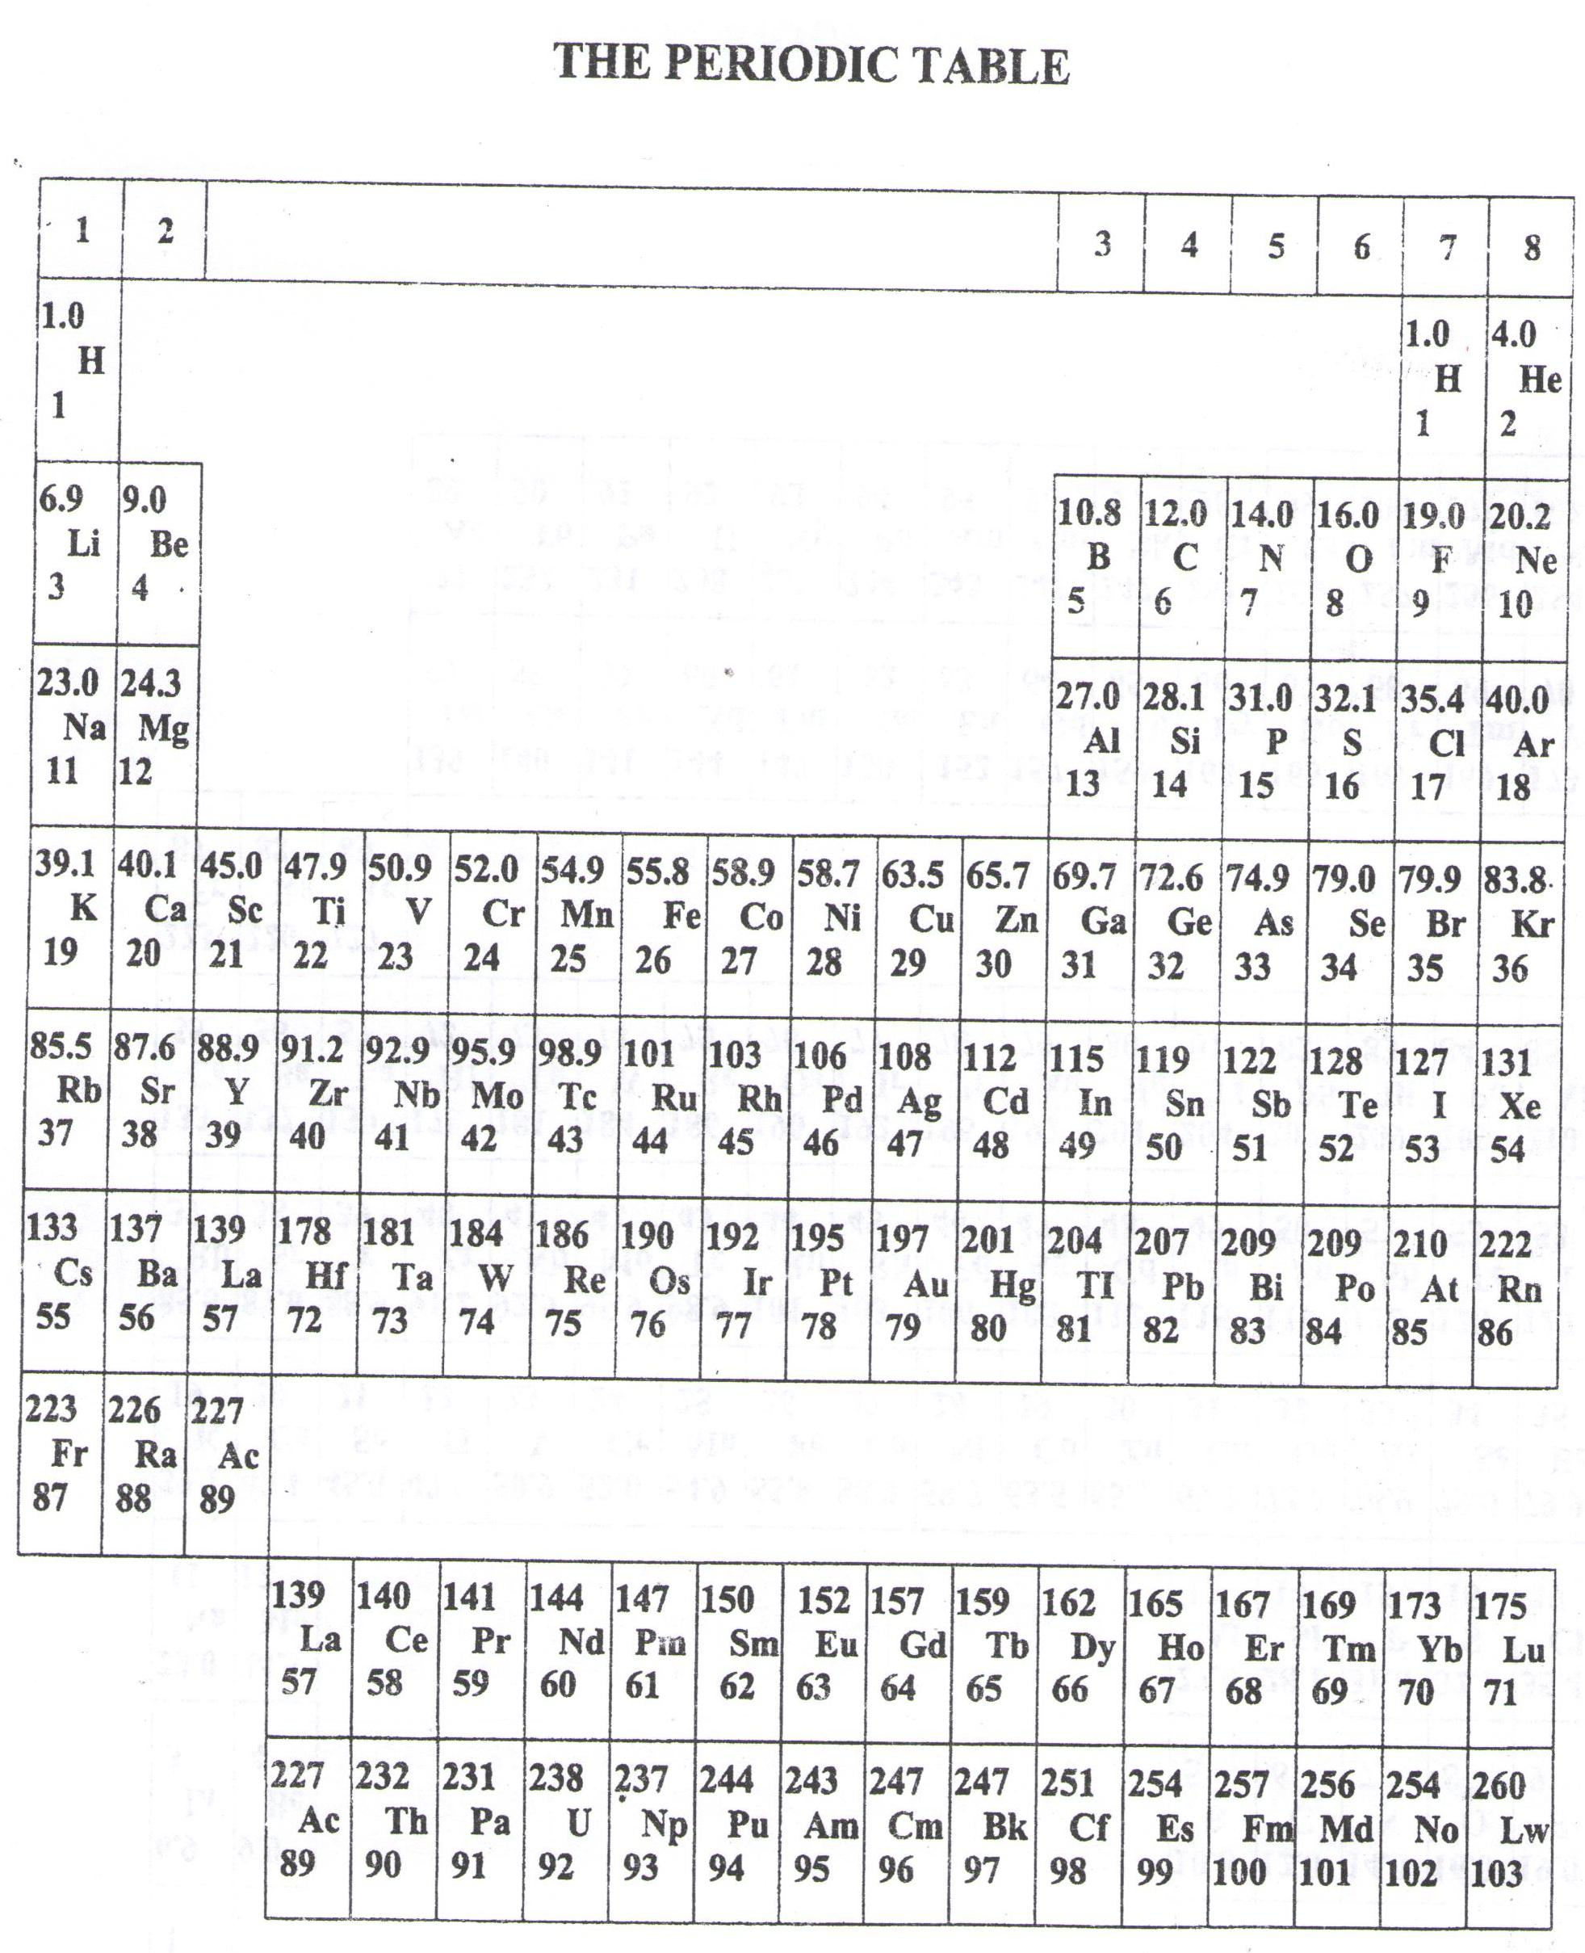

**END**